**Project Design Phase-II**

**Technology Stack (Architecture & Stack)**

|  |  |
| --- | --- |
| Date | 24 June 2025 |
| Team ID | LTVIP2025TMID30187 |
| Project Name | Optimizing User, Group, and Role Management with Access Control and Workflows |
| Mentor Name | Dr Shaik Salma Begum |
| Maximum Marks | 4 Marks |

**Technical Architecture:**

The Deliverable shall include the architectural diagram as below and the information as per the table1 & table 2

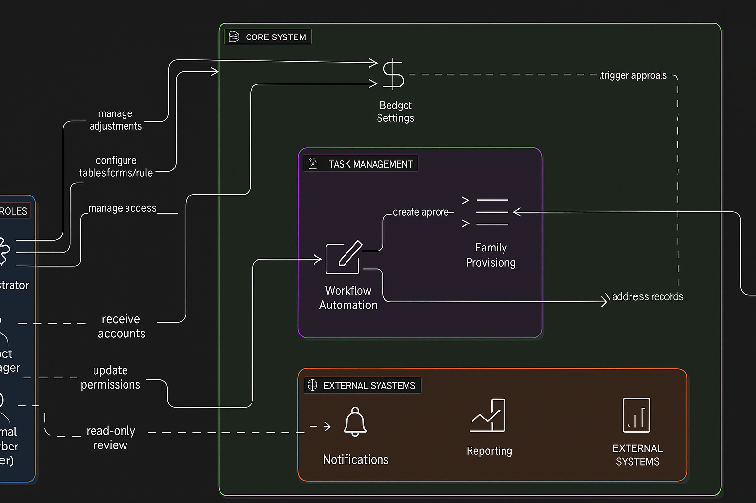

**Table-1 : Components & Technologies:**

|  |  |  |
| --- | --- | --- |
| Component | Description | Technology |
| User Interface | Web-based ServiceNow interface for managing users, roles, and tasks | ServiceNow UI Builder, Forms, Lists |
| Application Logic-1 | Dynamic behavior for forms, role-based field visibility, validations | ServiceNow Client Scripts, UI Policies, GlideForm API |
| Application Logic-2 | Automation of task assignment, role validation, and workflow transition | ServiceNow Flow Designer, Business Rules |
| Application Logic-3 | Trigger email notifications on status updates and assignment changes | ServiceNow Notification Engine |
| Database | Store user details, roles, tasks, workflow states, and logs | ServiceNow custom tables (Users, Roles, Tasks, Logs) |
| External API-1 | Allow integration with third-party task reporting or audit tools | ServiceNow REST API |
| Infrastructure (Server / Cloud) | Hosted ServiceNow PDI instance in the cloud | ServiceNow SaaS Cloud Platform |

**Table-2: Application Characteristics:**

|  |  |  |
| --- | --- | --- |
| Characteristics | Description | Technology |
| Open-Source Frameworks | Uses JavaScript for client and server logic within ServiceNow | JavaScript, AngularJS (optional) |
| Security Implementations | Role-based access control to manage user permissions and HTTPS security | ServiceNow ACLs, HTTPS, TLS |
| Scalable Architecture | Easily add new roles, workflows, or users as team grows | ServiceNow Cloud Platform, REST APIs |
| Availability | Accessible 24/7 during development via ServiceNow PDI | ServiceNow Cloud Infrastructure |
| Performance | Optimized load times and operations via caching and streamlined workflows | ServiceNow Caching, CDN support |